GS-VMAS Newsletter
January, 2023
We at GS-VMAS are looking forward to a 2023 with many exciting activities for both PhD students/residents and supervisors. For example, 18 PhD courses will take place this year and we are also planning seminars/workshops on career after the PhD, on predatory journals, about research ethics and on artistic visualization of science projects. Also don’t forget the seminar series running this spring: “Primary production of animal source food - systems perspective and assessment of environmental sustainability” – all at VH are welcome to join (zoom or on site). The first date is 31th of January and you are welcome to join at all occasions or just in occasional seminars of interest.
Upcoming seminars and workshops spring 2023
Seminar on predatory journals
March 1, 12.15-13.00
During this seminar librarian Olof Frank from SLU Library highlights the importance of publishing strategy and how to identify suitable journals to publish in. Unfortunately there is a market for dubious and potentially predatory publishers and journals. These journals are driven by financial self-interest at the expense of scholarship and science and often lack in publication standards and peer-review. The aim of the seminar is to give you tools how select suitable journal together with your research group and how to avoid falling into the predatory journal trap.
More information about the seminar and how to register will be announced by separate email as well as on GS-VMAS homepage GS-VMAS Planned activities | Externwebben (slu.se).
Career after PhD studies
March 17, 12.15-13.00
Interested in a career outside of Academia? Welcome to listen to Karl Ståhl who will describe his career journey from being a PhD student at the VH-faculty to where is today. Karl Ståhl is the State epizootiologist and Head of the Department of disease control and epidemiology at the National Veterinary Institute (SVA). He received a degree in Veterinary Medicine from SLU in 1998, and a Ph.D. in veterinary virology from the same university in 2006.
More information about the seminar and how to register will be announced by separate email as well as on GS-VMAS homepage GS-VMAS Planned activities | Externwebben (slu.se).
Seminars and PhD course on systems perspective in animal production
During spring 2023 GS-VMAS arrange 8 seminars on the topic “primary production of animal source food -systems perspective and assessment of environmental sustainability”.
The seminars are part of a PhD-course (P000007) and initiated by the faculty as part of its long-term investments in interdisciplinary research with the aim of developing knowledge about sustainable systems for food production.
Location: Room Framtiden, C-241A2034, Plan 2 MVM house (participation via Zoom possible)
Time: 13.15-16.30
Dates and topics:
31 January Crop production (course introduction 13.15-14.00)
14 February Carbon sequestration
7 March Biodiversity
14 March Greenhouse gases from animals -especially ruminants
28 March Emissions from manure
25 April Aquaculture, circular systems
2 May Side-streams, novel protein feeds, potential risks
9 May Sustainability assessment
23 May Student presentations
For more information about the seminars: GS-VMAS Planned activities | Externwebben (slu.se)
For more information and application to the course P000007: GS-VMAS Planned courses | Externwebben (slu.se)
Planned courses 2023
For 2023 we have the following planned courses:
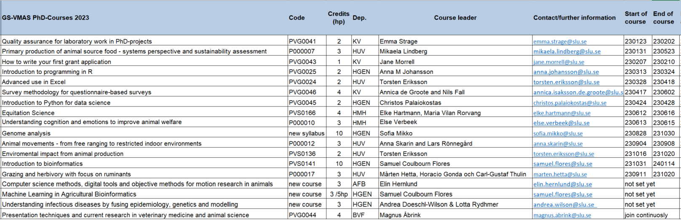
More information will be updated at the web www.slu.se/gs-vmas-planned-courses.
Presentation technique course at the VH Faculty
The course can be joined continuously by visiting https://slu-se.instructure.com/courses/1809 and clicking “Join the course” and logging in with your SLU account.
The course will include different workshops related to research presentation techniques - both to a scientific and a non-scientific audience. In addition, research students will also have practical training in giving seminars through presenting at the VH-faculty seminar series.
For more information: VH Presentation technique course | Externwebben (slu.se)
Upcoming PhD courses spring 2023
During spring 2023 we have the following upcoming courses:

P000007 Primary production of animal source food - systems perspective and assessment of environmental sustainability
Credits: 3
Course dates: January 31 - May 23, 2023 (230131, 230214, 230307, 230314, 230328, 230425, 230502, 230509, 230523)
Course poster
Course syllabus
Application to course

PVG0043 How to write your first grant application
Credits: 1
Course dates: February 7 - 10, 2023
Course poster
Course syllabus
Application to course

PVG0025 Introduction to programming in R
Credits: 2
Course dates: March 13 - 24, 2023
Course poster
Course syllabus
Application to course

PVG0024 Advanced use in Excel
Credits: 2
Course dates: March 28 - April 18, 2023 (scheduled course days: 230328, 230404, 230418)
Course poster
Course syllabus
Application to course

PVG0046 Survey methodology for questionnaire-based surveys
Credits: 4
Course dates: April 17 - June 2, 2023 (mainly digital with two physical meetings at Ultuna April 18 and May 23)
Course poster
Course syllabus
Application to course

PVG0045 Introduction to Python for data science
Credits: 2
Course dates: April 24 - 28, 2023
Course poster
Course syllabus
Application to course

PVS0166 Equitation science
Credits: 4
Course dates: June 12 - 16, 2023
Course poster
Course syllabus
Application to course

P000010 Understanding cognition and emotions to improve animal welfare
Credits: 3
Course dates: June 13-15, 2023 (preparations and assignments are required both before and after the course dates)
Course poster
Course syllabus
Application to course
SLU's general courses for PhD students
For more information regarding SLU's general courses in transferable skills, please visit: Doctoral courses | Medarbetarwebben (slu.se)
Do you have an idea for a seminar or a workshop?
GS-VMAS have funds available to grant money for seminars and/or workshops. If you have a visiting research partner or an opponent present for a dissertation it may be a great opportunity to combine this with arranging a seminar or workshop.
Please contact us at gs-vmas@slu.se and we will let you know whether there are funds available for your idea.

Administration of your PhD studies
If you have any questions regarding the administration of your PhD studies, such as registration, crediting for courses, all courses completed in Ladok, you may use Education Services’ joint e-mail address for PhD matters: us-phd-vh@slu.se
All the best from the coordinators and administrators for GS-VMAS
Miia, Anne-Lie, Göran and Susanna

